Tina Yetukuri

Per: 1

8/14/16

Daniel, Richard, Justin

Chromatography Lab Report

Introduction

Chromatography is the separation of components of a mixture by their distinctive attraction to the mobile phase and the stationary phase. The purpose of this experiment was to see how different colors would separate and how far they would travel in the same solution. Alcohol, the constant solution, was diluted with water and was placed in a beaker. Three strips of filter paper were cut and a dot was placed 2 cm from the bottom of the paper. Initial of lab members were placed near the dot on each strip of paper. All three papers were taped on a pencil and were set in a beaker along with the alcohol solution.

Method

Beaker, graduated cylinder, liquid, pencil, strips of filter paper, markers, tape, ruler are the materials needed to complete this experiment.

Procedure:

* Cut 3 strips of filter paper and place a dot on each strip of paper with the different color markers 2 cm from the bottom of the paper.
* Place initials of your name near the dot to represent it as a starting point.
* Lay the pencil horizontally on the table and tape the strips vertically onto the pencil. Make sure the strips are not too far apart that they won’t fit in a beaker. Place the pencil aside.
* Take a graduated cylinder and measure 10ml of alcohol and pour the liquid into a beaker. Measure 10ml of water and pour it in the same beaker as the alcohol to dilute it.
* Take the pencil with the strips and place in in the beaker along with the solution
* Wait for 20 minutes and record the data.

As a safety requirement during this lab, always wear a lab apron and goggles. Don’t let a flame near when dealing with alcohol.

Data

Quantitative

|  |  |
| --- | --- |
| Color of Marker | Distance Spread |
| Black | 4.8 cm |
| Red | 4.6 cm |
| Blue | 4.8 cm |

Qualitative Data

Black Marker: The black marker left behind color as it traveled up, and it got to the top the color started changing into a pale yellow.

Red Marker: The red marker didn’t leave any color behind. It just traveled upward not separating into different colors.

Blue Marker: The blue marker didn’t leave any color behind either but as it got to the middle it started separating into purple and blue.

Photos

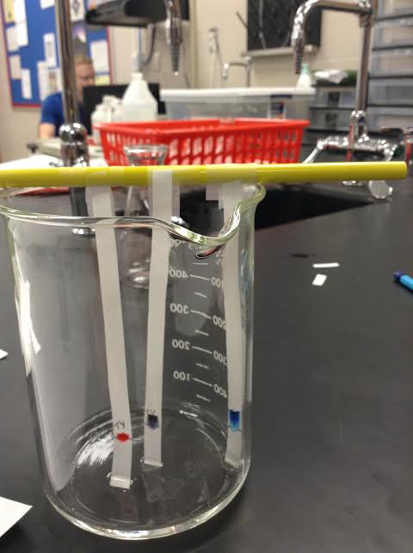

Picture taken after one minute in the solution.

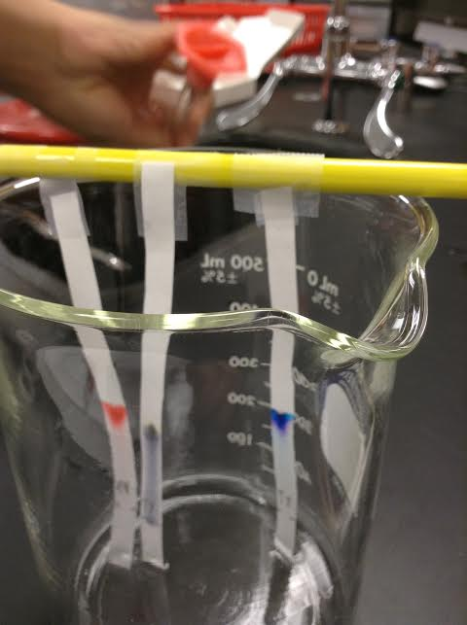

20 minutes in the solution.

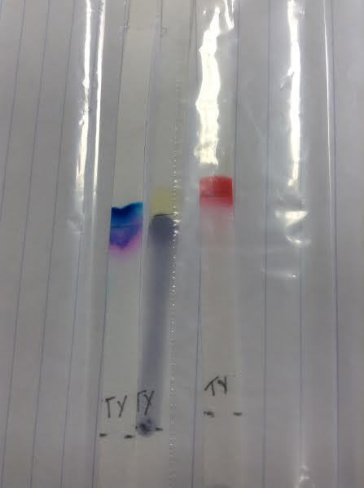

The final results and separation of colors.

Analysis

All three colors traveled up the average length of 4.7cm in the same solution. The distance traveled by the colors is based on the type of solution used. Any other color would probably travel the distance of 4.7 cm in the alcohol solution.

Graph

|  |  |  |  |  |
| --- | --- | --- | --- | --- |
| |  | | --- | | https://nces.ed.gov/nceskids/createagraph/images/corner_bottomleft.gif | | |  |  | | --- | --- | | |  | | --- | | https://nces.ed.gov/nceskids/createagraph/graphwrite.aspx?ID=24839bc94fe14d138fae310369cc6f2f&r=76607.170498&file=png | | |

Conclusion

All colors traveled the average length of 4.7 cm and two of the three separated into two different colors. The average distance spread was related to the solution. If another solution was used the distance might differ. The separation of colors is based on what two or more colors that one color is made of. And the different colors separated as it traveled up the paper. It could be learned from this lab that the distance that colors travel is based on the type of solution and the separation into different colors depends on the type of marker.